Note: Include this page only when adding / amending / deleting a document. If using this document as a record, this Revision History page can be omitted.

REVISION HISTORY
Revision no | Date | Description of Changes | Reason for Revision | Revised by | Approved by
0 | 2 Jun 14 | Initial document | Green Procurement | RDPlacido  WWRobles
1 | Apr. 8, 2016 | Added disclaimer when printing the document | For document control | RCGanal | WRRobles
TM-BR-MG- 11 Rev02, 10302015

I. Objective
To ensure that the AP Accountant has effectively assessed environmentally friendly products / services when evaluating or selecting for suppliers.

II. Responsibility
Accounts Payable Accountant
Unit Head

III. Reference
None

- Guidelines

- The AP Accountant should opt for products with Eco-labels, Quality Seals / Certification (e.g. ISO 9000) or other local eco-awards. Examples are the ff:
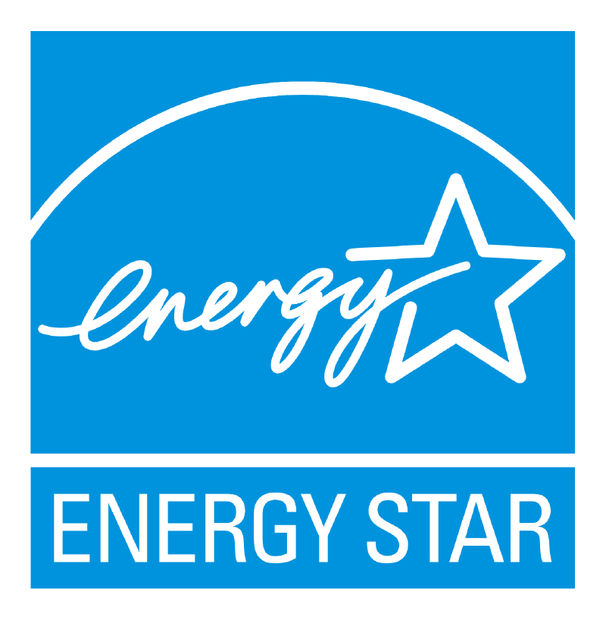 | Energy Star is a U.S. Environmental Protection Agency (EPA) voluntary program that helps businesses and individuals save money and protect our climate through superior energy efficiency.  Source: http://www.energystar.gov/about/
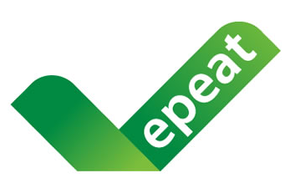 | EPEAT® is the definitive global rating system for greener electronics. Source: http://www.epeat.net/about-epeat/
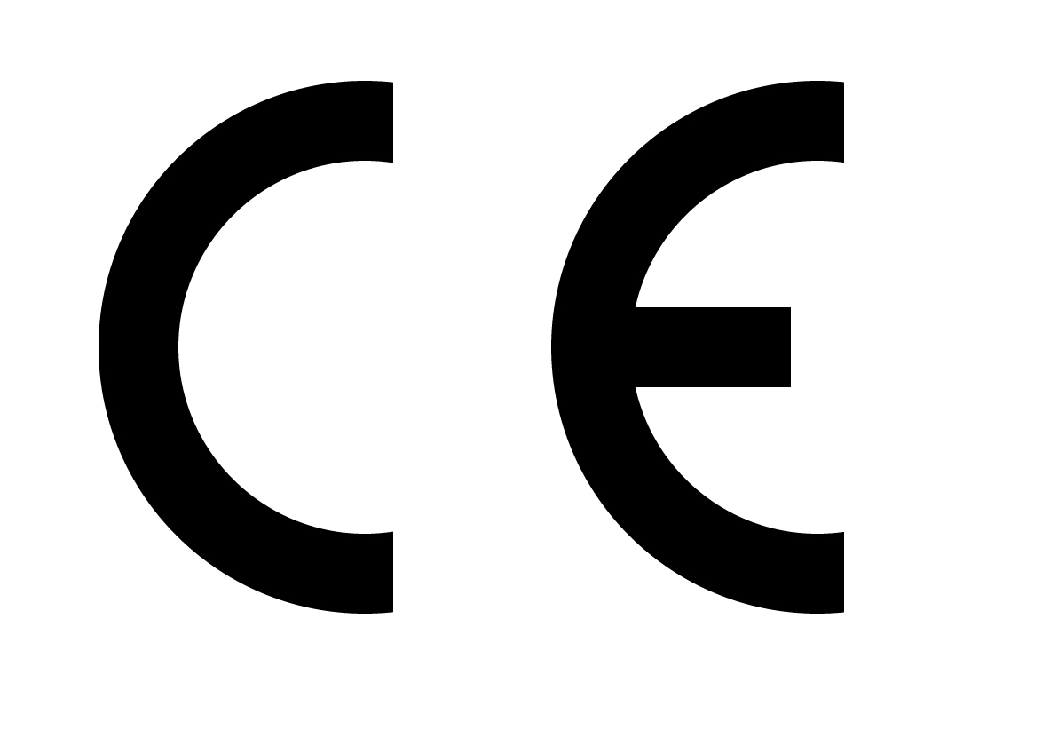 | CE marking indicates a product’s compliance with EU legislation and so enables the free movement of products within the European market.  Source: http://ec.europa.eu/enterprise/policies/single-marketgoods/cemarking/about-ce-marking/index_en.htm
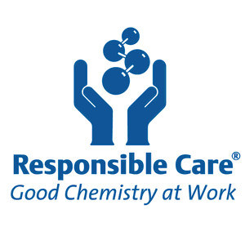 | Responsible Care® is the chemistry industry's commitment to sustainability. Its ethic and principles compel companies to innovate for safer and more environmentally friendly products and processes, and to work to eliminate harm throughout the entire life cycle of their products.  Source:http://www.canadianchemistry.ca/responsible_care/index.php/en/index#sthash.D2iYLSEP.dpuf
 | TCO Development advances sustainable IT. This means the manufacturing, use and recycling of IT products are carried out with regard to environmental, social and economic responsibility. Source: http://tcodevelopment.com/informations-for/purchaser/
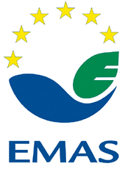 | EU Eco-Management and Audit Scheme (EMAS) is a management instrument developed by the European Commission for companies and other organisations to evaluate, report, and improve their environmental performance.  Source:http://ec.europa.eu/environment/emas/index_en.htm
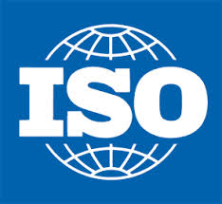  ISO 14001:2004  ISO 14004:2004 | ISO 14000 family addresses various aspects of environmental management. It provides practical tools for companies and organizations looking to identify and control their environmental impact and constantly improve their environmental performance. ISO 14001:2004 and ISO 14004:2004 focus on environmental management systems. Source:http://www.iso.org/iso/home/standards/management-standards/iso14000.htm
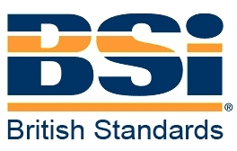  BS7750 | BS7750 is a specification for an environmental management system. The system is used to describe the company's environmental management system, evaluate its performance and to define policy, practices, objectives and targets; and provides a catalyst for continuous improvement.  Source: http://www.quality.co.uk/bs7750.htm
 | This Standard specifies environmental attributes and measurement methods for ICT and CE products according to known regulations, standards, guidelines and currently accepted practices. Source: http://www.ecma-international.org/publications/standards/Ecma-370.htm

- Check if the supplier will provide the following product information or if these are available on the product label / package:
  - Operating Instructions / Manuals
  - Safety and disposal notes
  - Technical Notes
  - Application & handling Instructions
  - Safety Data Sheets

- Avoid products with hazard symbols. Green products should be non-toxic biodegradable and safe.

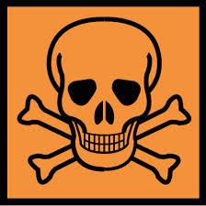  Toxicity |   Flammability |   Corrosiveness

- For PCs (desktop and notebook computers), monitors and servers, consider products that conform to Design for Environment programs (DfE).

e.g.
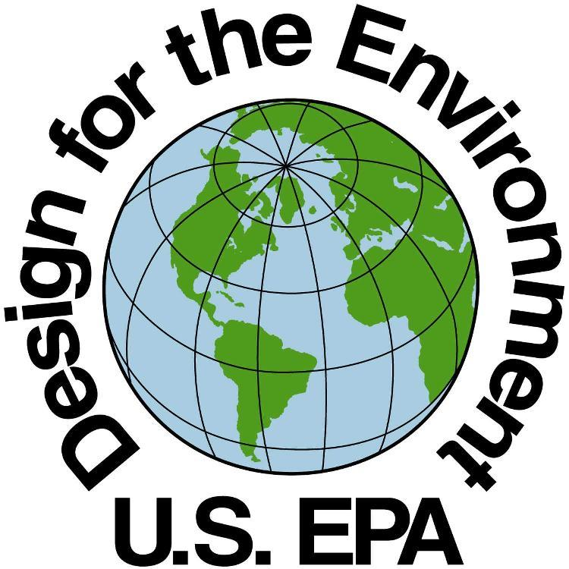 | EPA's Design for the Environment program helps consumers, businesses, and institutional buyers identify cleaning and other products that perform well, are cost-effective, and are safer for the environment. Source: http://www.epa.gov/dfe/

- Opt for products with minimal, recyclable packaging material. Look for a recycling symbol.

